Product Inventory Management System
Ideation Phase: Defining the Problem Statements
Project Details:
- Date: 08/03/2026
- Team ID: SWTID-2026-8952
- Project Name: Product Inventory Management System (Backend)
- Maximum Marks: 2 Marks
Customer Problem Statement Overview:
- The Customer Problem Statement framework assists in pinpointing the hurdles users encounter when handling product stock.
- Grasping the user's point of view empowers the team to architect a system that is safe, straightforward, and highly effective.
- Through the analysis of user requirements, this project concentrates on developing a functional inventory management application utilizing the MERN stack.

(Reference: Miro Customer Problem Statement Template)
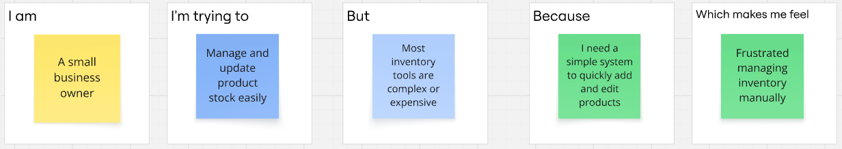
Defined Problem Statements:
Problem ID | I am (Customer) | I'm trying to... | But... | Because... | Which makes me feel...
PS-1 | A small business operator | Efficiently manage product inventory | Current tools are overly complex or costly | I require a straightforward system for rapid product addition and updates | Annoyed when managing inventory by hand
PS-2 | An independent online seller | Monitor available stock and pricing | Information gets misplaced without a unified platform | I need a protected dashboard where solely I can oversee my merchandise | Worried about misplacing crucial product details
PS-3 | A store manager | Consistently update inventory quantities | An accessible real-time CRUD system is lacking | I demand a quick and responsive web application to adjust stock at any moment | Uneasy when inventory data is obsolete
PS-4 | A startup founder | Keep products organized in a single location | Numerous inventory applications demand a difficult setup | I desire a lightweight, easy-to-use inventory platform | Overburdened by intricate software

